# Comparison Between two populations

Very important in analytics.

Chubby chunky example

**Matched Samples:** Same person we got two different readings

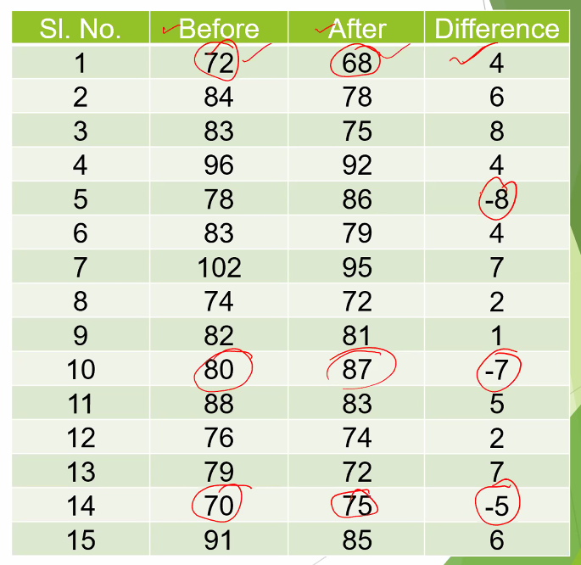

Difference (d) for Men (M) 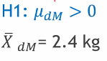

We know the distribution of X1_bar and X2_bar. These are unmatched samples and independent. Then we go for estimate difference.X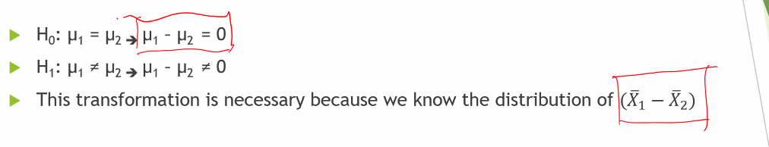

For linear combination of X1_bar and X2_bar each being normally distributed is also normally distributed.

Thus if we have matched samples we have to take difference in observations.

If we have unmatched samples we take difference in estimates.

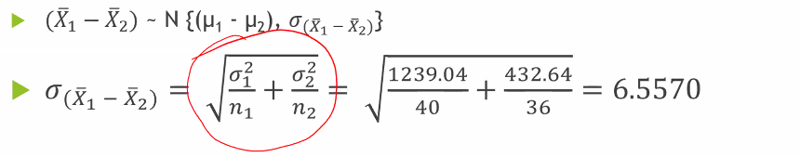

Need to prove the σ(X1_bar and X2_bar).

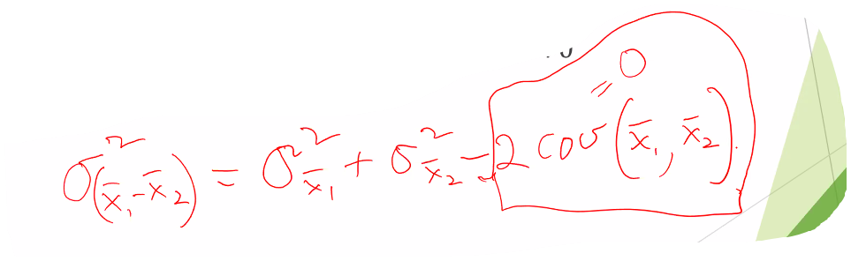….. self proof required.

Here assumed COV(X1_bar and X2_bar) ~ 0.

Practice problem.